ITL JOBS Changes

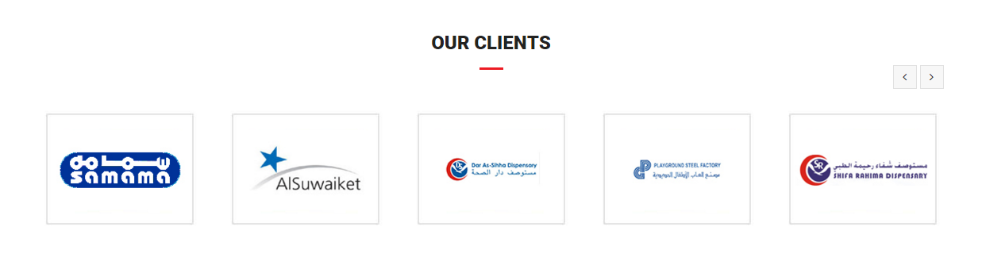

1. Remove box padding so that can reduce the box size. They need small boxes there…-**Fixed**

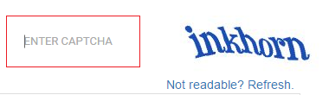

2. “Enter Captcha” should be replaced with “Enter Number”, and change captcha text to number. When you refresh captcha doesn’t reload the entire website use AJAX to reload captcha-**Fixed**



3. “SPECIFICATION/CERTIFICATION” should be “SPECIALISATION/CERTIFICATION”-**Fixed**

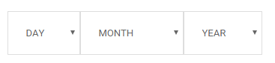

4. “Date of Birth” should be there as placeholder.-**Not fixed**

🗉

DATE OF BIRTH

5. Change text to UPLOAD YOUR CV-**Not fixed**

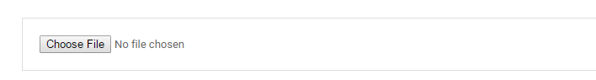

6. Remove a few from our concerns list: hydro-fit, PILOTS, shifa etc.-**Not fixed**



7. Registration form order should be changed:-**Not fixed**

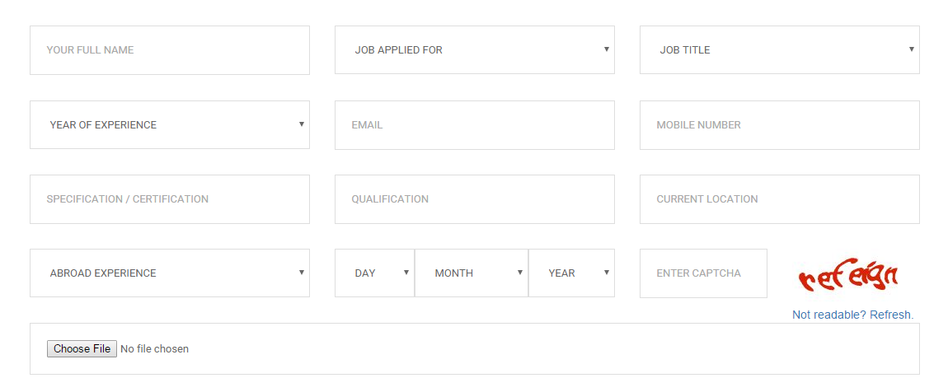

1. Title(dropdown): Mr, Mrs, Miss, Ms etc.
2. Full Name ( not your full name)
3. Date of Birth
4. Job Applied for
5. Industry (not Job title)
6. Years of experience( not year of experience)

Total yrs

YEARS OF EXPERIENCE

ABROAD

INDIA

Total years should be calculated by us and displayed in the total yrs box

1. specialisation
2. qualification
3. current location
4. captcha
5. Upload Your CV

8. **Fixed**



Changed to







ITL JOBS logo should be there in the red banner and ITL WORLD logo should be there in the right side